Machine Learning & Opioid Dependence

Parker DeBruyne - V00837207

Zeina Ebeid - V01011703

Health Information Science, University of Victoria

HINF 140: Introduction to The Canadian Health Care System

Dr. Trudy Pauluth-Penner

HINF 280: Biomedical Fundamentals

Dr. Erdem Yazganoblu

March 23rd, 2023



**Table of Contents**

**Introduction 1**

Scope 2

Acknowledgements 3

**The Opioid Epidemic 3**

Current Status & Prescription Law 4

**Modern Healthcare for Opioid Dependence 6**

How Machine Learning Works 7

Predictive Risk Factors 7

Preventing Disease Contraction 10

Assisting in Diagnosis 13

Generating Treatment Plans 15

Predicting Overdose 16

Linking It All Together 18

**Conclusion 19**

**References 20**

# 

# 

# Introduction

The opioid crisis is one of the most severe public health issues in Canadian history and remains a prominent discussion in Canadian public health. The rapid increase in the circulation and misuse of opioids has led to an alarming overdose emergency in Canada. This crisis is multifaceted, and while it is primarily rooted in inappropriate prescribing practices and illegal drug markets, it also has deep roots in socioeconomic inequity, mental health, and a plethora of other factors. In order to obtain statistical data on the opioid crisis and brainstorm effective harm-reduction strategies regarding opioid dependency, it is imperative to understand critical points where intervention is crucial. This can often be defined by simply spotting the signs where an individual may develop an opioid dependency before it actually happens. However, it is unrealistic to expect prescribing physicians and pharmacists to recognize risky patterns and behaviors among so many patients. Here, machine learning models may prove more efficient for analyzing long-term data on the opioid crisis and recognizing patterned behaviors that increase an individual's likelihood of developing opioid dependency. Our discussion will aim to explore history and current status of the opioid crisis, critical points where our current system fails, and lastly, suggest the incorporation of machine learning into Canada’s healthcare systems to explore the opioid crisis at an individual level rather than at a societal level.

## Scope

The scope of this essay is limited to discussing the history and current status of Canada’s opioid crisis, and exploring the efficacy of machine learning in predicting risk factors based on quantitative data. This discussion will not consider the ethics or legalities of the matter. Existing databases and technology systems will be briefly acknowledged but not explored.

## Acknowledgements

We would like to thank our professors Dr. Trudy Pauluth-Penner and Dr. Erdem Yazganoglu for their support and encouragement, our colleagues Tam Westby and Jessica Carroll for their time and contribution, and John Stewart.

# The Opioid Epidemic

In Canada, opioid prescriptions first emerged in the early 1900s for pain management treatment. A few decades later, opioid dependency was highlighted in healthcare. Primarily, First Nations peoples and Indigenous peoples, particularly those residing in reserves displayed evident signs of substance abuse and dependency (Statistics Canada, 2022). Socioeconomic determinants of health were a significant contributor to growing cases of opioid dependencies in their communities—one being racial discrimination in health practices towards First Nations and Indigenous peoples as a result of colonization, (Statistics Canada, 2022). Opioid prescriptions increased rapidly, and opioid-related sales in hospitals and pharmacies grew by over 3000% by 1980 (Belzak & Halverson, 2018). By 2008, non-medical opioid use became the fourth most prevalent form of substance abuse after alcohol, tobacco, and cannabis (Belzak & Halverson, 2018). In 2016, over 20 million opioid prescriptions were dispensed—making Canada the second-largest consumer of opioids after the United States of America—with an estimated 2458 overdose-related deaths (Belzak & Halverson, 2018; Tyndall, 2018). In April 2016, the province of British Columbia declared the opioid crisis a public health emergency, and introduce a rapid upscale of naloxone distribution (a temporary overdose inhibitor) amongst vulnerable communities - However, this effort yielded insignificant results as over 1000 overdose-related deaths were reported in the first eight months of 2017 (Tyndall, 2018). Apart from prescription opioids, a core component of the opioid crisis can be attributed to the illegal distribution of synthetic opioids such as fentanyl.

## Current Status & Prescription Law

Since the declaration of a public health emergency, both the federal government of Canada and provincial legislative bodies have implemented several prescribing laws and guidelines to address the opioid crisis. In 1996, during the beginning of the opioid crisis, the federal government introduced the Controlled Drugs and Substances Act (CDSA) which outlines regulations around controlled substances including opioids. It classifies drugs into several categories based on their potential for abuse and addictive properties (Government of Canada, 2023). It also regulates the production and distribution of precursor chemicals that can be used to make illicit drugs (Government of Canada, 2023). Similarly, many provinces have introduced Prescription Monitoring Programs (PMP) to monitor the prescribing and dispensing of controlled substances (Furlan et al, 2014). These programs allow healthcare providers to manually track a patient's prescription history and identify potential abuse or misuse of prescription drugs. The PMP is best utilized with electronic healthcare systems which allow healthcare providers to access necessary information about their patients without being required to consult prior or primary prescribing physicians. The BC Ministry of Health has developed guidelines for the use of opioid agonist treatment (OAT), which is a type of medication-assisted treatment for opioid addiction. These guidelines encourage healthcare providers to prescribe OAT as a first-line treatment for opioid addiction (British Columbia Pharmacy Association, 2023).

With stricter regulations, opioid prescribing has declined in Canada since 2016. According to the Canadian Institute for Health Information (CIHI), vulnerable populations studied for opioid prescriptions displayed a 14.3% to 12.3% decrease in regular opioid prescriptions from 2013 to 2018 (Library of Parliament, 2021). During this period, more individuals stopped long-term opioid use, and fewer were prescribed treatment plans including long term opioid use (Library of Parliament, 2021). However, although this seems like a step in the right direction, these statistics are limited to populations observed and do not include margins of individuals in communities considered low risk for opioid dependency. Thus, this can explain the additional estimated 1000 overdose-related deaths observed in 2020 compared to previous years (Library of Parliament, 2021). It is important to note that the COVID-19 pandemic may have also contributed to this number. Although opioid prescriptions are declining, many individuals who have either already developed an opioid dependency, or likely may, still have access to opioids through unsafe and unregulated means. One frequently observed issue is doctor hopping. The frequency of physicians who actively participate in opioid harm reduction through their practices varies - Thus if an individual is refused a prescription for an opioid from one doctor who integrates harm reduction within their practice, they may simply visit a different doctor who may provide them with a prescription without further investigation of their medical profile (Sansone & Sansone, 2012).

Additionally, individuals are being prescribed opioids in large quantities, typically more than they require. A study conducted by Kumar et al observed a median of 60 pills of pain management opioids being prescribed to post-procedural patients. Of these 60, a reported median of 32 pills were left unused (Kumar et al, 2017). A notable issue here is that many patients are ill-informed on appropriate methods of drug disposal, and will often leave unfinished opioids in their medicine cabinets. Then, these opiates will often end up being used at a later time as a method of pain management even when the dosage and medication type is inappropriate for the situation(Kumar et al, 2017). Additionally, they may also share these opioids with friends and family whom they may not be aware of their individual risk factors for developing an opioid dependency (Kumar et al, 2017).

While opioid prescription rates are declining, yet opioid dependency continues to persist and worsen, it is imperative that the Canadian healthcare system requires more extensive methods of researching the opioid crisis, and exploring solutions that extend beyond drug distribution regulation - Here, an individual focused approach must be considered.

# Modern Healthcare for Opioid Dependence

Health Informaticians commonly experiment with machine learning in hospitals every day, and with the ocean of global data growing wider, they foresee positive outcomes for its use. Regarding the opioid epidemic, scientists successfully used machine learning in a test environment to identify patients with opioid dependency in electronic health records (EHRs) and achieved 92% accuracy based on data from lab tests and vital signs (Ellis, 2019). The challenge however, lies in the correct usage of machine learning systems and in supplying relevant information to the right people in healthcare—especially within the context of a person’s journey through opioid dependency.

## How Machine Learning Works

Though many different machine learning models (MLMs) exist, they all operate on the same principle: they recognize and apply patterns to new situations after learning what to look for in existing data. Typically, this requires a tremendous amount of data, but once trained, a MLM can analyze millions of new data points over a short period of time.

There exists two types of MLMs: (1) Supervised Learning Models, and (2) Unsupervised Learning Models. Supervised models require labeled training data; they are ‘told’ what to look for. Unsupervised models aim to achieve a given task without guidance and they sometimes discover unintuitive relationships between variables. Both models recalibrate their algorithms based on millions of trials until an acceptable accuracy percentage is achieved, and both have their place in the future of healthcare. This paper, however, focuses on selecting data features to help supervised models predict, prevent, diagnose, and manage opioid dependency—and how relevant members of healthcare may utilize the results.

## Predictive Risk Factors

Certain life events can leave a person predisposed to contracting addiction—if doctors are aware of a patient’s risk of developing dependence before writing prescriptions, it may incentivize them to lower the dosage or find an alternative medication for pain management. In general, early-life trauma and large disruptions to a person’s social network may cause them to manage physical and emotional pain with substance abuse, (Maté, 2008; Silvia, 1990; Waldinger, 2015). This intuitive fact is supported by research and includes the following non-exhaustive list: (1) psychological trauma—including physical or emotional abuse, (2) preadolescent sexual abuse, (3) childhood adversity, (4) poor social support, and (5) a family history of substance abuse, (Cohen, 1982; Webster, L. R. 2017). Other events include parental divorce, neglect, social stigma, being adopted, the death of a family member, frequent job loss, criminal activity, mental health difficulties, and significant familial moves such as immigration, (Thompson, 2008; Mayo Clinic, 2018, February 16). Moreover, studies in Canada have shown that indigenous populations are at increased risk of opioid dependency—but this is a result of generational trauma, not demographics, and further supports the causative relationship between abuse and addiction, (Hatt, 2022; Webster, P. C. 2013). Leveraging data from a patient's early life is complicated, and comes with ethical challenges, but many schools have adopted electronic records; it may be enough for a MLM to use *classroom attendance* to gauge a child’s social health and inform medical records. If done ethically, data from social media sites could also be included.

A patient’s risk calculation is further supported by factors that appear in EHRs and BC PharmaCare. The single strongest predictor includes a history of substance abuse—such as drugs, alcohol, and smoking, (Webster, L. R. 2017). Friends and family sometimes share left-over pills from opioid prescriptions, not understanding the addictive nature of these medications, and MLMs could use prescription records to cross-reference family profiles, (Kumar, 2017; Lisa, 2018). If health informaticians train MLMs on elementary school, high school, PharmaCare, PharmaNet, and EHR databases, they could provide a prescribing doctor with a calculated risk assessment for each patient and an optimized dose. Many of these databases are publicly accessed and filled with anonymous data and are a convenient training ground for MLMs, (BC Ministry of Health, 2021).

Regarding gender and age, Hatt (2022) observed that males between the ages of 30 to 39 account for 76% of Canadian overdoses in 2021—though, this makes sense when considered critically and should not be used as a causative predictor of dependence. Opioids are prescribed for pain management; any job that increases the likelihood of physical injury will correlate with opioid dependence, and since many labor jobs are predominantly occupied by men, we cannot use gender as a ML data label. We can use the symptom of *musculoskeletal pain*, however, from patient health care records because treatment for such conditions tend to be chronic, and chronic use is a causative factor of dependance, (Dale, Buckner-Petty, Evanoff, & Gage 2021). Moreso, older construction workers—who are susceptible to chronic pain—have higher rates, while workers without access to health insurance have lower rates; this implies the illuminating statement that opioid prescriptions increase the risk of opioid dependence, which gives us a crucial point to focus on in the journey through addiction: the prescription itself, (Dong, Brooks, & Cain 2020; Lisa, & Jessica 2018). **Figure 1.** shows a summary of potential input data for a supervised MLM:

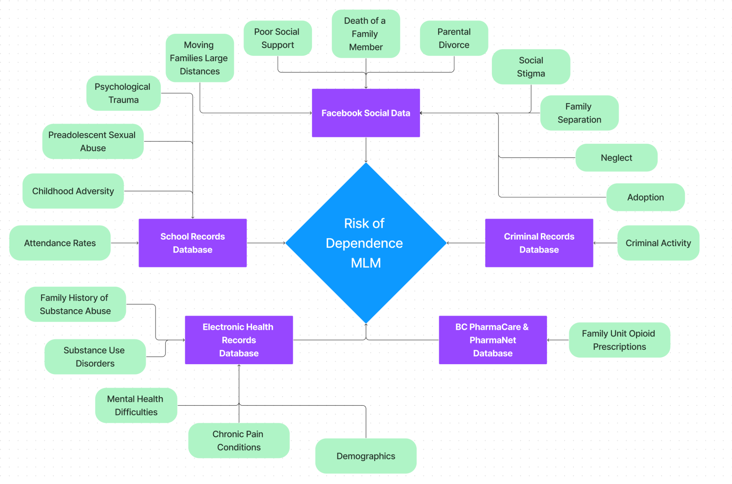**Figure 1:** *Training Data for a Risk of Dependence MLM.*

## Preventing Disease Contraction

The following is a true case of opioid dependence as a result of multiple system failures: John Stewart was adopted at 3 years old after the divorce of his parents. He struggled with learning disabilities in school, got held back a year, and moved in with his alcoholic, biological, father at the age of 14. His friends introduced him to cannabis in grade 8, and he got involved in criminal activity before dropping out of school in grade 10. He attended a youth correctional facility for a time, but got involved with a local gang upon release. He couldn’t hold a steady job and relied on illegal activity for his income as he aged. During an accident on a boat, he injured his knee and was prescribed oxycontin for chronic pain. A few years later—at age 39—he broke his hip and was given a second, erroneous, prescription for morphine tablets. Both prescriptions were refilled regularly until he died at age of 46 from overdose. John was never once assessed for opioid dependence, or treated; his story is one of many, (Carroll, 2022). Had John’s risk of addiction been assessed early by counselors at his school, the correctional facility, or by his two prescribing doctors, he may have had not only a different outcome, but a different life.

Outside of healthcare, preventing addiction is a process of social inclusion: youth mentorship programs—such as Big Brothers Big Sisters—have yielded significant results yet still rely on risk detection, funding, and volunteers, (Tierney, 1995). A MLM that identifies at-risk students could help teachers pair children with role models and shape their life trajectory. Software systems that utilize MLMs could help the education system work tangentially with healthcare—provided ethical standards are met and data privacy maintained.

Opioids are effective for managing emergency pain, and have a place in healthcare, but their use for chronic pain is dangerous and may not be as effective as originally believed; long term use shows significant diminishing returns after 1 month, (Dowel, 2016; Heikkila, & Ristmagi, 2022). Additionally, the amount of prescribed opioids in North America quadrupled in the last two decades while rates for reported pain have remained constant; 54% of pills go unused and investigations have shown that most patients have a surplus of opioids at home they do not dispose of, (Maughan, 2016; Kumar, 2017). Finally, doctors do not write prescriptions for opioids consistently; some refuse to prescribe opioids at all, while others do not check for existing prescriptions—as in John Stewart’s story, (Carroll, 2022; Scripps News, 2017).

A new MLM that calculates dosage, frequency, and duration could help doctors write accurate prescriptions for patients with chronic pain. Working in conjunction with the previous MLM, this Opioid Prescription MLM could choose the medication, check for contraindications, display prescription metrics, show an addiction risk percentage, and even recommend alternative pain medications, (Nicol, 2017). Doctors could override these recommendations if needed, but a warning confirmation would signal before the paperwork is faxed to a pharmacy. Accuracy for the MLM could be achieved by analyzing the hundreds of thousands of overdose death records that exist in healthcare—along with their prescription histories. **Figure 2.** illustrates the training data required from EHRs and BC PharmaCare:

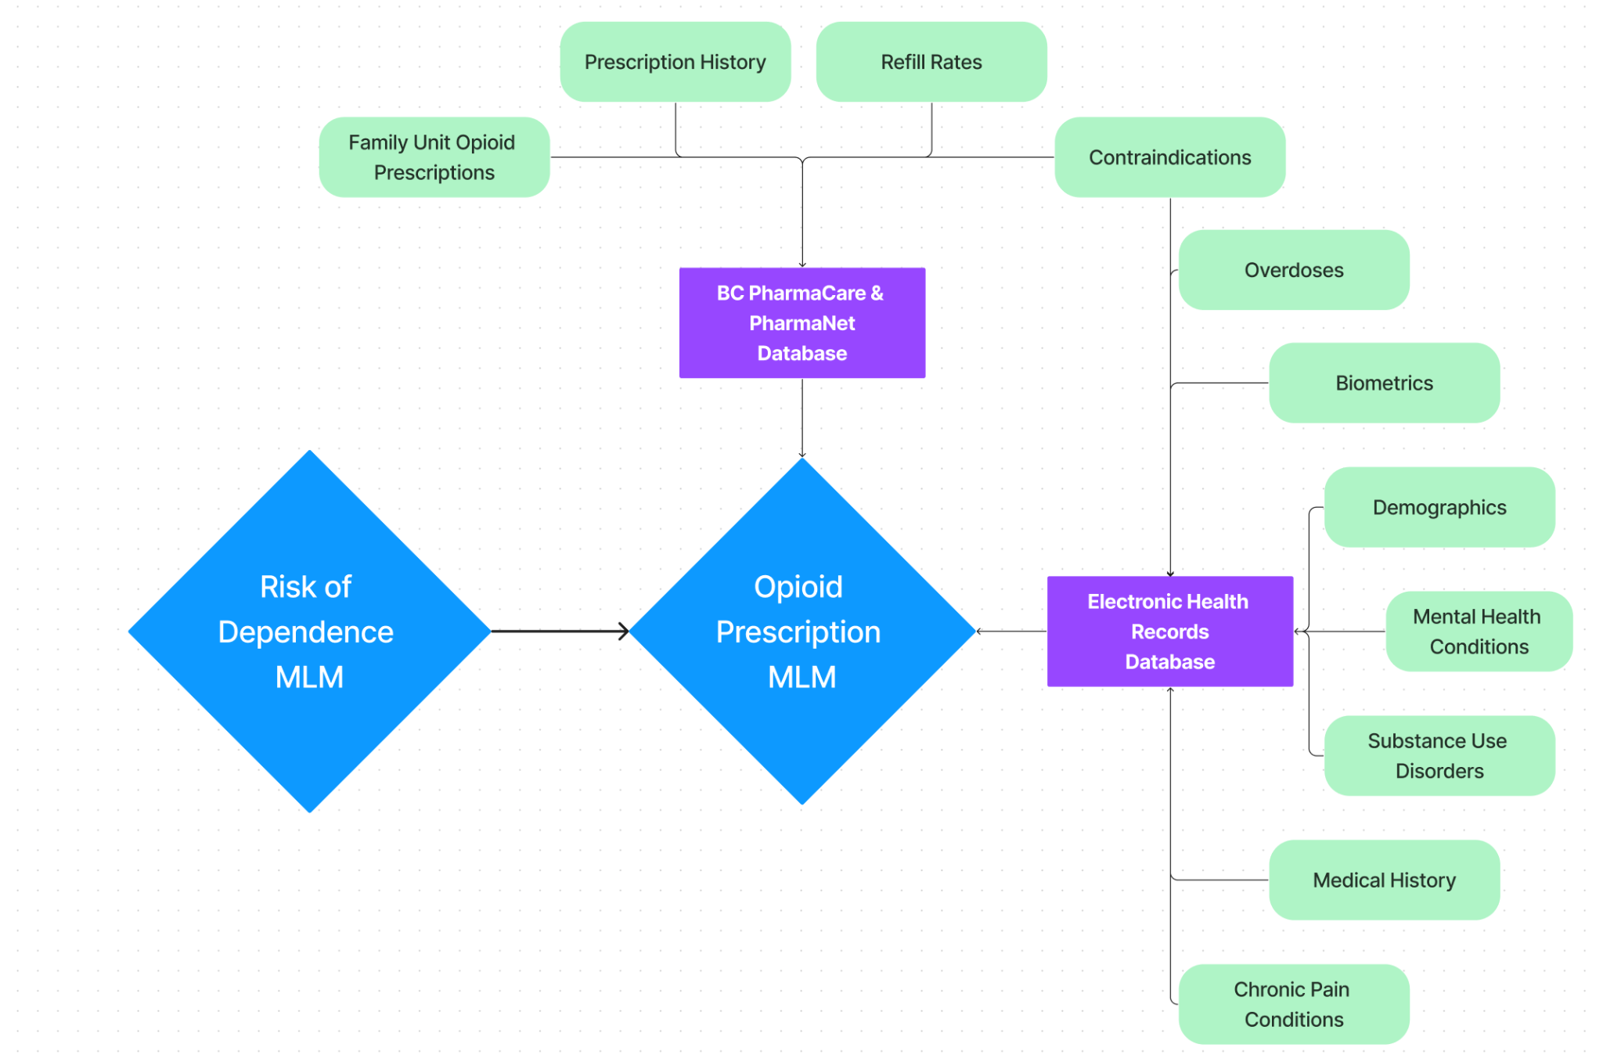

**Figure 2:** *Training Data for an Opioid Prescription Calculation MLM.*

## Assisting in Diagnosis

Let’s say that a patient with chronic pain was prescribed an appropriate dose over a safe period of time, but through some other means they still developed opioid dependence—how would we detect it before they overdose? Thankfully, data scientists already designed and tested a MLM to address exactly this question and yielded remarkable results, (Ellis, 2019). They trained a deep learning model on EHRs and discovered that certain features in lab tests and vital signs give significant indication of opioid dependence in patients—with 92% accuracy. In order of significance, the top five indicative features include the following: red blood cell distribution width (%), albumin (g/dl), bilirubin direct (mg/dl), lymphocytes (%), and protein total (g/dl). These results may be more effective for detecting opioid dependence than traditional methods—such as urine testing—because a MLM can check millions of records in the same time it takes a patient to get through a Canadian hospital waiting room. Additionally, urine toxicology tests are prone to false positives and negatives, and are only viable during the short period of time where opioids are detectable in a patient’s urea. Furthermore, the 11-point-questionnaire for diagnosing Opioid Use Disorder in the DSM5 requires an in-person assessment that collects qualitative, not quantitative, responses and is susceptible to patients being in denial about their situation, doctor bias, and often requires a patient’s condition to decline substantially before treatment is considered, (American Psychiatric Association, 2013). If lab tests were scheduled regularly for patients with prescriptions, early diagnosis and treatment options could be presented before dependence became unmanageable. The Opioid Prescription MLM could be used jointly with this Diagnosis MLM to adjust dosage and suggest alternative medications, as in **Figure 3.** If a patient is showing signs of dependence from within EHR data, the MLM could notify their prescribing doctor and most recent pharmacist to encourage an assessment and discuss treatment options.

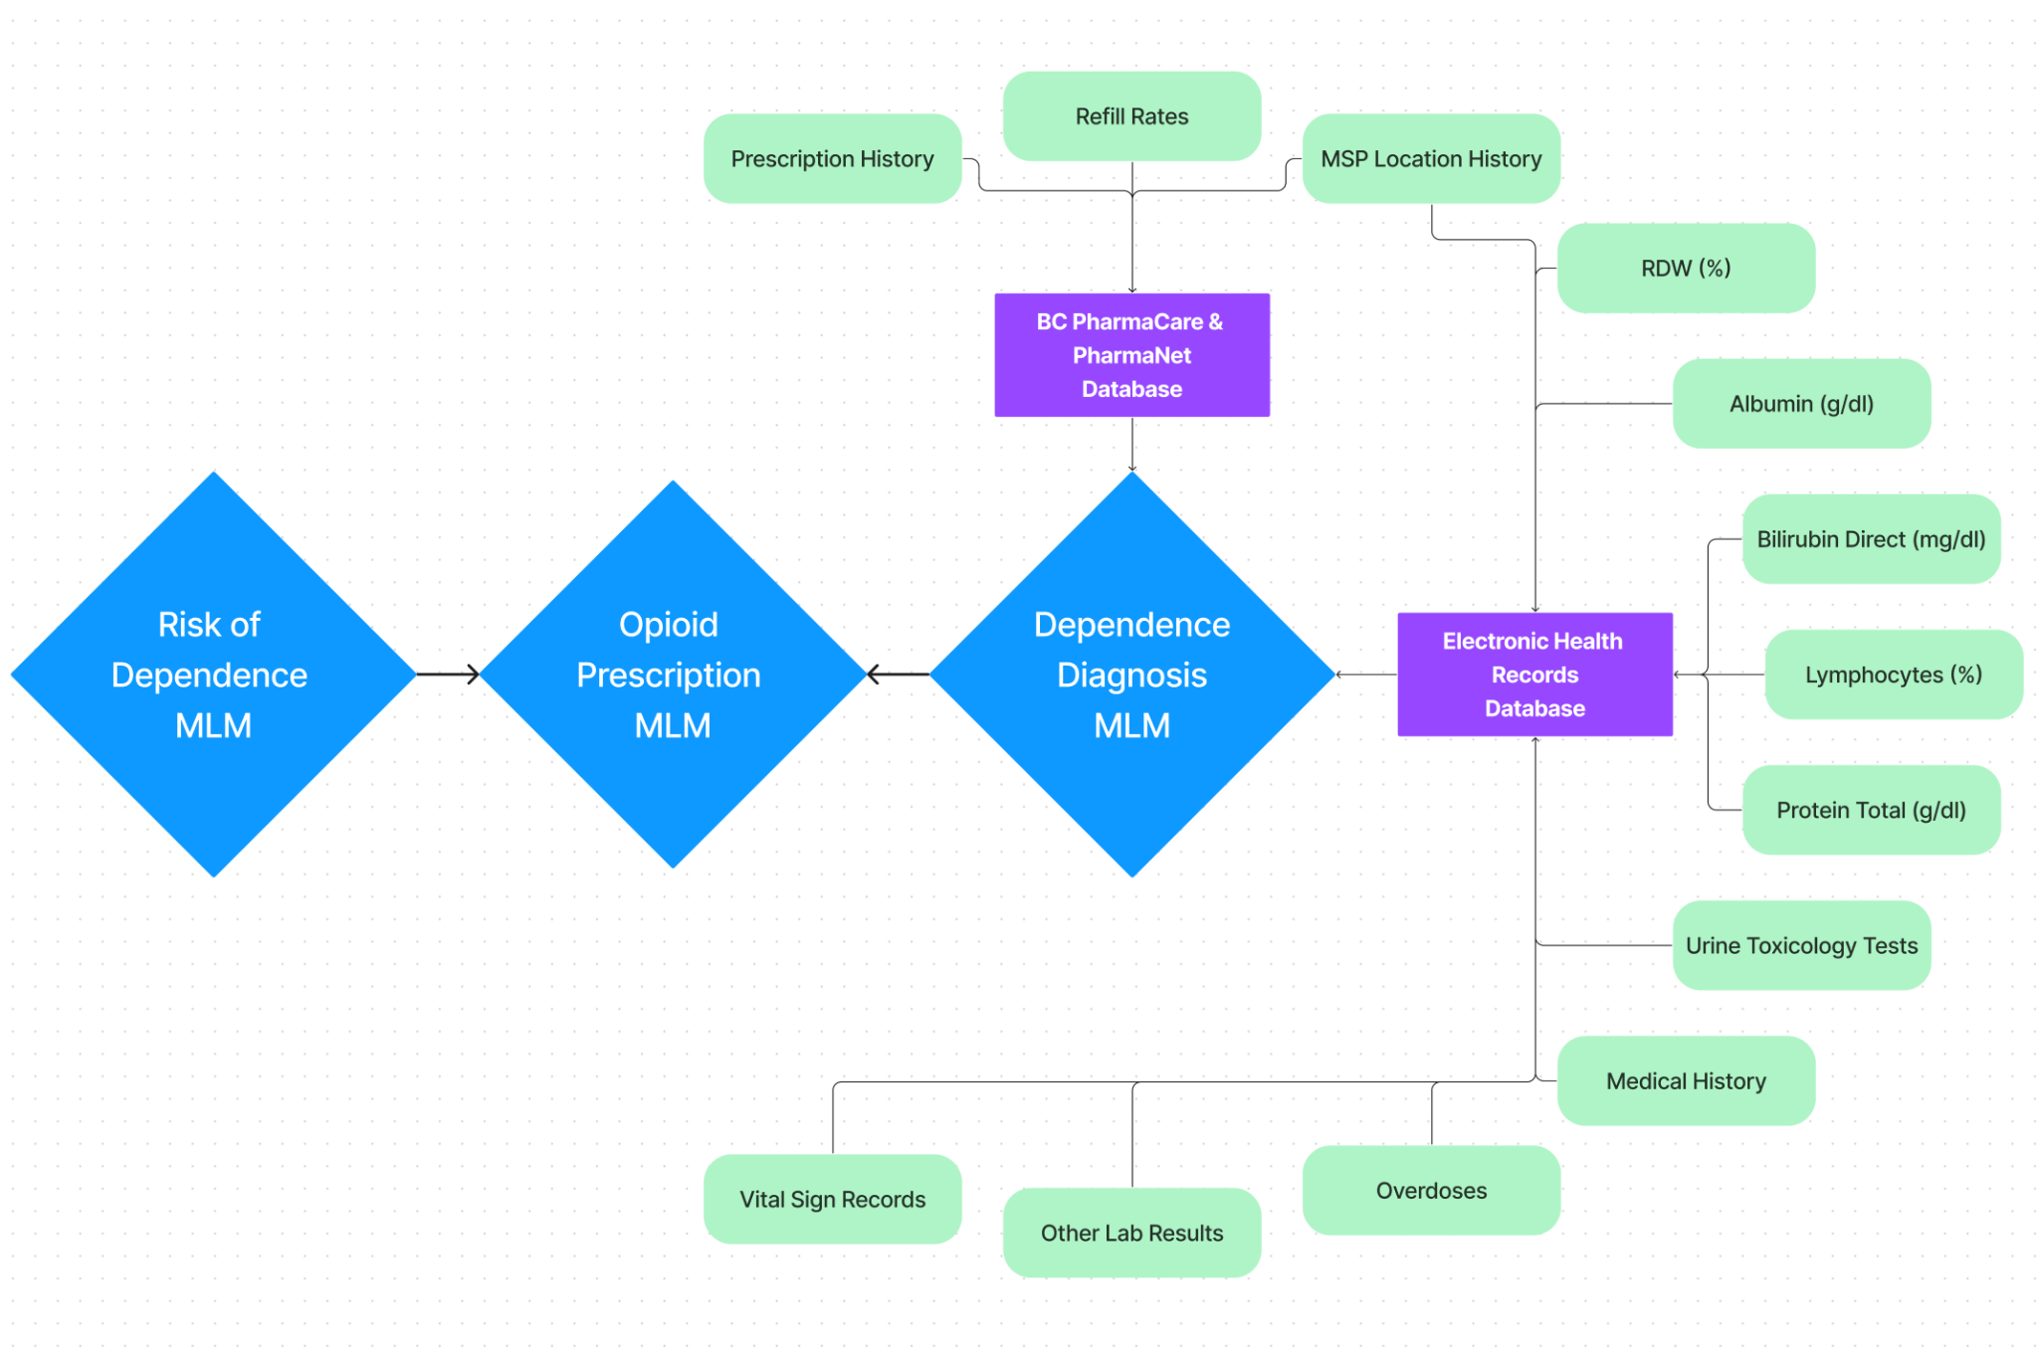

**Figure 3:** *Training Data for a Dependence Diagnosis MLM.*

Outside the hospital system, if family members begin to see signs of abnormal behavior that indicate the progression of dependence, they should call a local pharmacy or hospital to notify a doctor of their loved one’s condition. Treating opioid dependence requires the effort of a community and the sooner treatment options are available to a patient the better their outcomes. Signs to look for include; consuming prescription opioids in ways other than prescribed, such as crushed and snorted, injected, or dissolved in alcohol; taking opioids in the absence of pain; hostile mood swings; changes in sleep patterns; borrowing medication from others; “losing” medication; early refills; trying different doctors for additional prescriptions; risky behavior; and poor decision-making. If you find yourself worrying about your family member’s drug use, withdrawing from them to avoid mood swings, or making excuses for their behavior to others, it is strongly recommended to accompany your loved one during their next follow up visit and express your concerns to their doctor. A patient is far more likely to recover when their family members lovingly refuse to enable their disease, (Mayo Clinic, 2018, May 09). It is important to remember that opioid dependence is not a choice; there are real, biophysical, aspects of this disease that cause tremendous amounts of pain for afflicted individuals—noradrenaline floods their body during withdrawals and causes severe muscle aches, stomach pain, fever, vomiting, anxiety, diarrhea, stress, and opioid cravings (DeBruyne, 2023).

## Generating Treatment Plans

One of the most effective ways to help patients recover from opioid dependence is to first reduce their current dosage slowly over many months then transition them to a different opioid that does not build drug tolerance as easily—such as methadone or buprenorphine. With a success rate of around 30%, treatment requires a tremendous amount of willpower, peer support, and doctor guidance, (DeBruyne, 2023; Hser, 2015). Short term rehabilitation is unrealistic since it takes a long time for the body to repair synapses and rebalance noradrenaline levels, (Zandbergen, 2017). If health professionals trained a MLM on EHRs from recovered patients, cross referenced the files with PharmaCare, and utilized the Opioid Prescription MLM, they could give a long-term ‘tapering plan’ to doctors and suggest alternative medications for their patients, as displayed in **Figure 4**. Opioid tapering treatment should not happen suddenly; careful calculation is required to prevent patients from turning to street drugs as they struggle to cope with lower doses, (Dowell, 2019).

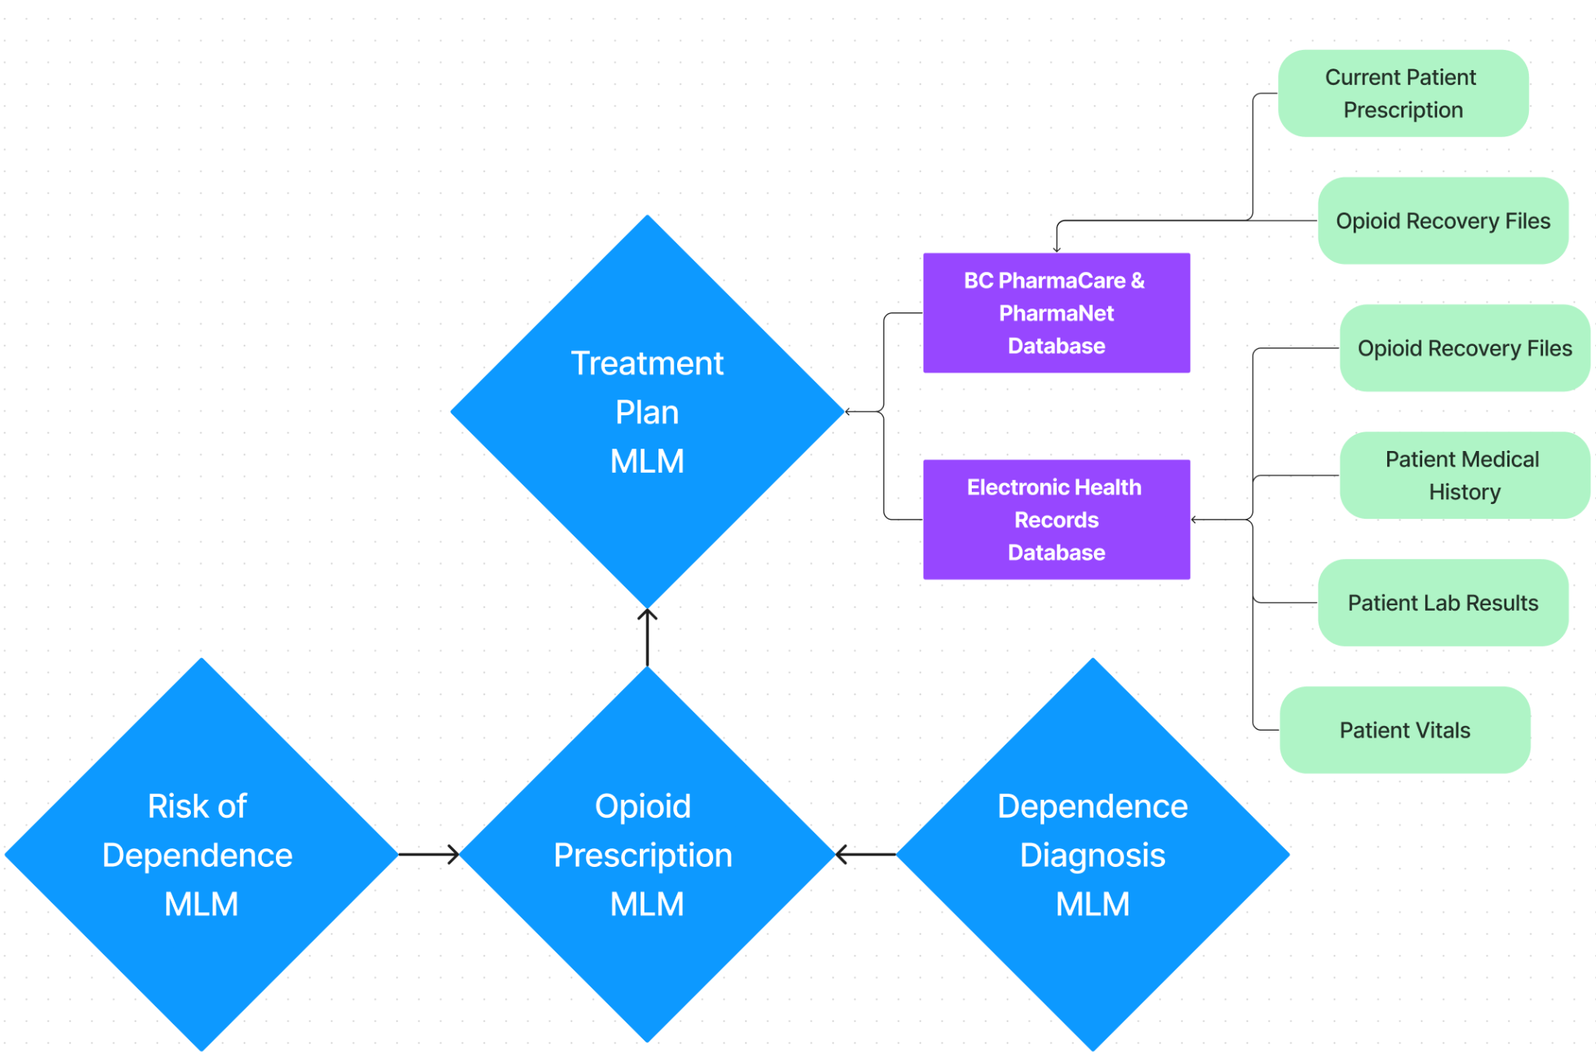

**Figure 3:** *Training Data for a Treatment Plan MLM.*

## Predicting Overdose

Machine learning was successfully used in 2019 to identify low, medium, and high-risk groups of patients that are at risk of overdose, and including a similar model with other MLMs would create an effective information system, (Lo-Ciganic, 2019). The study examined data from Medicare beneficiaries in the United States with at least one opioid prescription and discovered the following features as predictors: sociodemographics, health status, and patterns of opioid use. Additionally, a study in 2017 discovered other factors: renal disease, pancreatic disease, history of substance abuse, mental health disorders, benzodiazepine co-prescribing, antidepressant co-prescribing, recent release from prison, recent release from abstinence-based treatment centers, sleep apnea, heart or pulmonary complications, and pain intensity, (Webster, L. R. 2017). Similar to the initial model used for assessing risk of dependence, this new model for predicting overdoses would rely on both EHRs and social data, as seen in **Figure 4**. When included in the larger system, this MLM would monitor patient files identified by the Dependence Diagnosis MLM and alert emergency services, family members, or emergency contacts. As 91% of overdose deaths happen in private rooms, notifying family members would be the most appropriate, (Somerville, 2017).

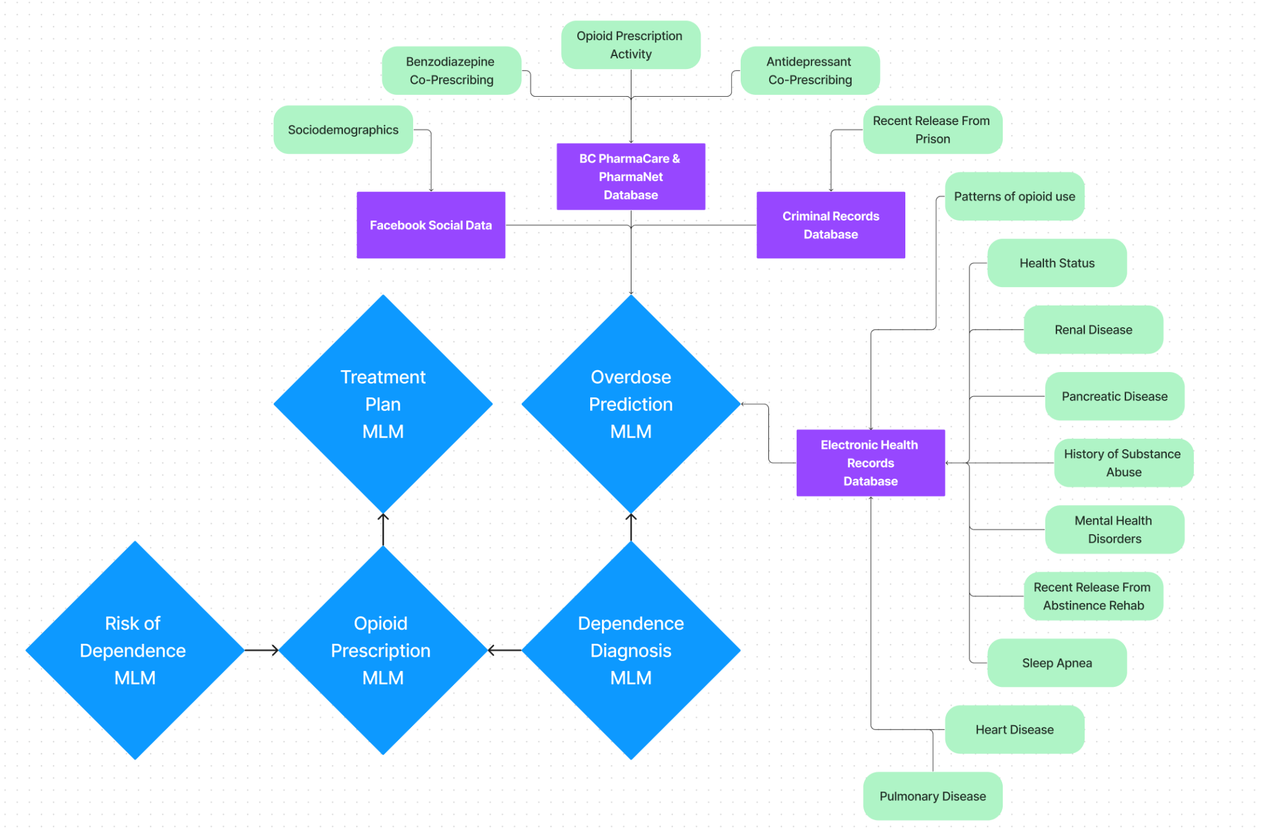

**Figure 4:** *Training Data for an Overdose Prediction MLM.*

## Linking It All Together

There are three crucial moments in a patient’s journey through opioid dependence where interventions can be assisted by machine learning: (1) when the initial prescription is written, (2) when dependence starts, and (3) when risk of overdose becomes severe. **Figure 5** illustrates a patient’s journey through these moments and their interactions with healthcare professionals:

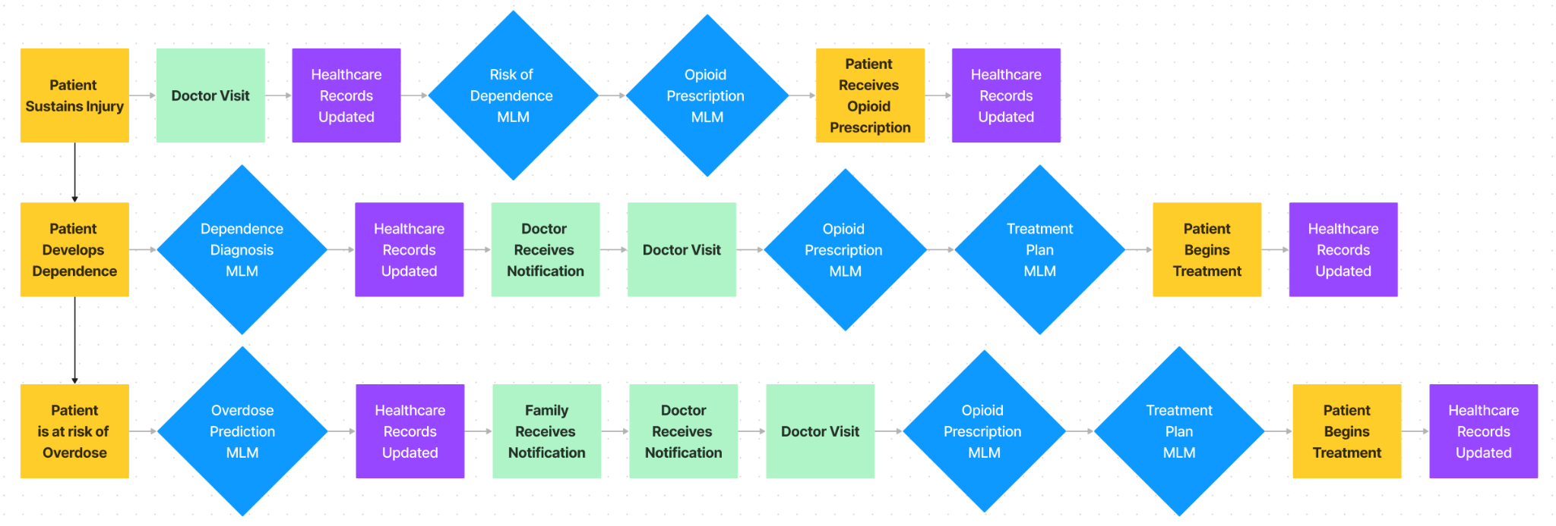**Figure 5:** *Crucial Moments in Opioid Dependence, and Machine Learning Interventions.*

The most effective first step is creating accurate opioid prescriptions in healthcare. Expansion of other MLM systems could take place afterward, but preventing the disease from taking root is the most important. Conveniently, the Opioid Prescription MLM and the Dependence Diagnosis MLM are also the most feasible to build given existing technology and expansive EHRs. Their combination creates an iterative loop where patients have dosages cinched down to an optimal level of effectiveness versus risk, **Figure 6**. Afterward, the Risk of Dependence MLM for early life factors could be built, and although there are challenges with data privacy laws its importance in the prevention of addiction is paramount and may be accomplished ethically if done with care.

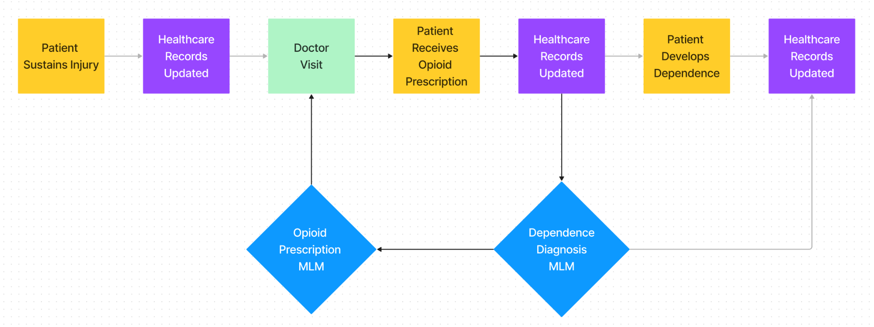

**Figure 6:** *An iterative loop for optimizing opioid prescriptions with Machine Learning models.*

# Conclusion

On average, 20 Canadians die each day due to opioid overdose, (Public Health Agency of Canada, 2022). Canada has faced a long and tragic history with opioid dependence, but with modern advances in healthcare and machine learning there are promising and practical solutions. The challenge, however, lies in systemic change within hospitals and national prescription habits—no small order—and creating ethical information systems legally. The uplifting fact, however, is that the technology to predict and prevent addiction already exists and is simply waiting to be used.

# References

American Psychiatric Association (2013). Diagnostic and Statistical Manual of Mental

Disorders, Fifth Edition,. Washington, DC, American Psychiatric Association page 541.

Retrieved March 21, 2023, from

<https://www.asam.org/docs/default-source/education-docs/dsm-5-dx-oud-8-28-2017.pdf>

BC Ministry of Health, (2021). Medical Services Plan data set | Population Data BC. Retrieved

March 21, 2023, from <https://www.popdata.bc.ca/data/health/msp>

Belzak, L., & Halverson, J. (2018). The opioid crisis in Canada: a national perspective.

La crise des opioïdes au Canada : une perspective nationale. *Health promotion and*

*chronic disease prevention in Canada : research, policy and practice*, *38*(6),

224–233. Retrieved March 21, 2023, from <https://doi.org/10.24095/hpcdp.38.6.02>

Carroll, J., Westby, T. (2022). Chronic Opiate Dependency and The Story of John Stewart.

University of Victoria, Dr. Erdem Yazganoblu, HINF 280.

Cohen, F. S., & Densen-Gerber, J. (1982). A study of the relationship between child abuse and

drug addiction in 178 patients: Preliminary results. Child Abuse & Neglect, 6(4),

383-387. Retrieved March 21, 2023, from <https://www.sciencedirect.com/science/article/abs/pii/0145213482900813>

Dale, A. M., Buckner‐Petty, S., Evanoff, B. A., & Gage, B. F. (2021). Predictors of long‐term

opioid use and opioid use disorder among construction workers: Analysis of claims data.

American journal of industrial medicine, 64(1), 48-57. Retrieved March 21, 2023, from

<https://onlinelibrary.wiley.com/doi/abs/10.1002/ajim.23202>

DeBruyne, P. (2023). Opioid Dependency and Abuse. University of Victoria, Dr. Erdem

Yazganoglu, HINF 280.

Dong, X. S., Brooks, R. D., & Cain, C. T. (2020). Prescription opioid use and associated factors

among US construction workers. American journal of industrial medicine, 63(10),

868-877. Retrieved March 21, 2023, from

<https://onlinelibrary.wiley.com/doi/abs/10.1002/ajim.23158>

Dowell, D., Haegerich, T. M., & Chou, R. (2016). CDC guideline for prescribing opioids for

chronic pain—United States, 2016. Jama, 315(15), 1624-1645. Retrieved March 21,

2023, from <https://jamanetwork.com/journals/jama/article-abstract/2503508>

Dowell, D., Haegerich, T., & Chou, R. (2019). No shortcuts to safer opioid prescribing. New

England Journal of Medicine, 380(24), 2285-2287. Retrieved March 21, 2023, from

<https://www.nejm.org/doi/full/10.1056/NEJMp1904190>

Ellis, R. J., Wang, Z., Genes, N., & Ma’ayan, A. (2019). Predicting opioid dependence from

electronic health records with machine learning. BioData mining, 12(1), 1-19. Retrieved

March 21, 2023, from

<https://biodatamining.biomedcentral.com/articles/10.1186/s13040-019-0193-0>

Furlan, A. D., MacDougall, P., Pellerin, D., Shaw, K., Spitzig, D., Wilson, G., & Wright,

J. (2014). Overview of four prescription monitoring/review programs in

Canada. *Pain research & management*, *19*(2), 102–106. Retrieved March 21, 2023, from

<https://doi.org/10.1155/2014/634171>

Hatt, L. (2022). The Opioid Crisis in Canada, HillStudies. Retrieved March 21, 2023, from

<https://lop.parl.ca/sites/PublicWebsite/default/en_CA/ResearchPublications/202123E#4>

Hser, Y. I., Evans, E., Grella, C., Ling, W., & Anglin, D. (2015). Long-term course of opioid

addiction. Harvard review of psychiatry, 23(2), 76-89. Retrieved March 21, 2023, from

[https://journals.lww.com/hrpjournal/Abstract/2015/03000/Long_Term_Course_of_Opioid](https://journals.lww.com/hrpjournal/Abstract/2015/03000/Long_Term_Course_of_Opioid_Addiction.3.aspx)

[_Addiction.3.aspx](https://journals.lww.com/hrpjournal/Abstract/2015/03000/Long_Term_Course_of_Opioid_Addiction.3.aspx)

Heikkila, H., & Ristmagi, A. (2022). Effect of Opioid Use on Results of Interventional Back

Pain Management on Patients With Suspected Face-mediated Chronic Back Pain. Pain

Physician, 25(5), E733. Retrieved March 21, 2023, from

<https://pubmed.ncbi.nlm.nih.gov/35901484/>

Kumar, K., Gulotta, L. V., Dines, J. S., Allen, A. A., Cheng, J., Fields, K. G., ... & Wu, C. L.

(2017). Unused opioid pills after outpatient shoulder surgeries given current perioperative

prescribing habits. The American Journal of Sports Medicine, 45(3), 636-641. Retrieved

March 21, 2023, from

<https://journals.sagepub.com/doi/abs/10.1177/0363546517693665?journalCode=ajsb>

Lisa, B., & Jessica, H. (2018). Evidence synthesis-The opioid crisis in Canada: a national

perspective. Health promotion and chronic disease prevention in Canada: research, policy

and practice, 38(6), 224. Retrieved March 21, 2023, from

[https://www.canada.ca/en/public-health/services/reports-publications/health-promotion-c](https://www.canada.ca/en/public-health/services/reports-publications/health-promotion-chronic-disease-prevention-canada-research-policy-practice/vol-38-no-6-2018/evidence-synthesis-opioid-crisis-canada-national-perspective.html)

[hronic-disease-prevention-canada-research-policy-practice/vol-38-no-6-2018/evidence-sy](https://www.canada.ca/en/public-health/services/reports-publications/health-promotion-chronic-disease-prevention-canada-research-policy-practice/vol-38-no-6-2018/evidence-synthesis-opioid-crisis-canada-national-perspective.html)

[nthesis-opioid-crisis-canada-national-perspective.html](https://www.canada.ca/en/public-health/services/reports-publications/health-promotion-chronic-disease-prevention-canada-research-policy-practice/vol-38-no-6-2018/evidence-synthesis-opioid-crisis-canada-national-perspective.html)

Lo-Ciganic, W. H., Huang, J. L., Zhang, H. H., Weiss, J. C., Wu, Y., Kwoh, C. K., ... & Gellad,

W. F. (2019). Evaluation of machine-learning algorithms for predicting opioid overdose

risk among medicare beneficiaries with opioid prescriptions. JAMA network open, 2(3),

e190968-e190968.

<https://jamanetwork.com/journals/jamanetworkopen/article-abstract/2728625>

Maté, G. (2008). In the realm of hungry ghosts: Close encounters with addiction. Random House

Digital, Inc.. Retrieved March 21, 2023, from

[https://books.google.ca/books?hl=en&lr=&id=HRS0YeEGXiwC&oi=fnd&pg=PA7&dq=](https://books.google.ca/books?hl=en&lr=&id=HRS0YeEGXiwC&oi=fnd&pg=PA7&dq=g+mate+addiction&ots=BL9Aq_0lR5&sig=fMBpDUk8OnwEBoZ5Ttkgau9fhK8#v=onepage&q=g%20mate%20addiction&f=false)

[g+mate+addiction&ots=BL9Aq_0lR5&sig=fMBpDUk8OnwEBoZ5Ttkgau9fhK8#v=one](https://books.google.ca/books?hl=en&lr=&id=HRS0YeEGXiwC&oi=fnd&pg=PA7&dq=g+mate+addiction&ots=BL9Aq_0lR5&sig=fMBpDUk8OnwEBoZ5Ttkgau9fhK8#v=onepage&q=g%20mate%20addiction&f=false)

[page&q=g%20mate%20addiction&f=false](https://books.google.ca/books?hl=en&lr=&id=HRS0YeEGXiwC&oi=fnd&pg=PA7&dq=g+mate+addiction&ots=BL9Aq_0lR5&sig=fMBpDUk8OnwEBoZ5Ttkgau9fhK8#v=onepage&q=g%20mate%20addiction&f=false)

Maughan, B. C., Hersh, E. V., Shofer, F. S., Wanner, K. J., Archer, E., Carrasco, L. R., & Rhodes,

K. V. (2016). Unused opioid analgesics and drug disposal following outpatient dental

surgery: a randomized controlled trial. Drug and alcohol dependence, 168, 328-334.

Retrieved March 21, 2023, from

<https://www.sciencedirect.com/science/article/abs/pii/S0376871616302563>

Mayo Clinic. (2018, May 09). How to tell if a loved one is abusing opioids. Mayo Clinic; Mayo

Clinic Staff. Retrieved March 21, 2023, from <https://www.mayoclinic.org/diseases-conditions/prescription-drug-abuse/in-depth/how-to-tell-if-a-loved-one-is-abusing-opioids/art-20386038>

Mayo Clinic. (2018, February 16). How opioid addiction occurs. Mayo Clinic; Mayo Clinic

Staff. Retrieved March 21, 2023, from <https://www.mayoclinic.org/diseases-conditions/prescription-drug-abuse/in-depth/how-opioid-addiction-occurs/art-20360372>

Nicol, A. L., Hurley, R. W., & Benzon, H. T. (2017). Alternatives to opioids in the

pharmacologic management of chronic pain syndromes: a narrative review of randomized, controlled, and blinded clinical trials. Anesthesia and analgesia, 125(5), 1682. <https://www.ncbi.nlm.nih.gov/pmc/articles/PMC5785237/>

Public Health Agency of Canada, Federal, provincial, and territorial Special Advisory

Committee on the Epidemic of Opioid Overdoses, (2022). Opioid- and Stimulant-related

Harms in Canada. Ottawa: Public Health Agency of Canada; December 2022. Retrieved

March 21, 2023, from

<https://health-infobase.canada.ca/substance-related-harms/opioids-stimulants/>

Sansone, R. A., & Sansone, L. A. (2012). Doctor shopping: a phenomenon of many

themes. *Innovations in clinical neuroscience*, *9*(11-12), 42–46.

Silva, P. A. (1990). The Dunedin multidisciplinary health and development study: a 15 year

longitudinal study. Paediatric and Perinatal Epidemiology, 4(1), 76-107. Retrieved March 21, 2023, from <https://onlinelibrary.wiley.com/doi/abs/10.1111/j.1365-3016.1990.tb00621.x>

Scripps News. (2017). New tactics for doctors prescribing opioids. On YouTube. Retrieved

March 21, 2023, from <https://www.youtube.com/watch?v=p4cVQLejYXc>

Somerville, N. J., O’Donnell, J., Gladden, R. M., Zibbell, J. E., Green, T. C., Younkin, M., ... &

Walley, A. Y. (2017). Characteristics of fentanyl overdose—Massachusetts, 2014–2016.

Morbidity and Mortality Weekly Report, 66(14), 382. Retrieved March 21, 2023, from <https://www.ncbi.nlm.nih.gov/pmc/articles/PMC5657806/>

Statistics Canada. (2021). Opioid-related deaths in Canada, 2020. Retrieved from

<https://www150.statcan.gc.ca/n1/pub/82-003-x/2021012/article/00002-eng.htm>

Tierney, J. P. (1995). Making a Difference. An Impact Study of Big Brothers/Big Sisters.

Retrieved March 21, 2023, from <https://eric.ed.gov/?id=ED390973>

Thompson Jr, R. G., Lizardi, D., Keyes, K. M., & Hasin, D. S. (2008). Childhood or adolescent

parental divorce/separation, parental history of alcohol problems, and offspring lifetime

alcohol dependence. Drug and alcohol dependence, 98(3), 264-269. Retrieved March 21,

2023, from <https://www.sciencedirect.com/science/article/abs/pii/S0376871608002445>

Tucker, S., & Keefe, A. (2021). 2021 Report on work fatality and injury rates in Canada.

unpublished report, University of Regina, 21. Retrieved March 21, 2023, from

[https://www.uregina.ca/business/assets/faculty_staff/2021-Report-on-Workplace-Fatalitie](https://www.uregina.ca/business/assets/faculty_staff/2021-Report-on-Workplace-Fatalities-and-Injuries-2021-Oct-21.pdf)

[s-and-Injuries-2021-Oct-21.pdf](https://www.uregina.ca/business/assets/faculty_staff/2021-Report-on-Workplace-Fatalities-and-Injuries-2021-Oct-21.pdf)

Tyndall M. (2018). An emergency response to the opioid overdose crisis in Canada: a

regulated opioid distribution program. *CMAJ : Canadian Medical Association journal = journal de l'Association medicale canadienne*, *190*(2), E35–E36. <https://doi.org/10.1503/cmaj.171060>

Waldinger, R. (2015). What makes a good life. Lessons from the longest study on happiness.

Retrieved March 21, 2023, from <http://www.giuliotortello.it/materiali/80_years_study_hapiness_harvard.pdf>

Webster, L. R. (2017). Risk factors for opioid-use disorder and overdose. Anesthesia &

Analgesia, 125(5), 1741-1748. Retrieved March 21, 2023, from <https://journals.lww.com/anesthesia-analgesia/fulltext/2017/11000/risk_factors_for_opioid_use_disorder_and_overdose.41.aspx>

Webster, P. C. (2013). Indigenous Canadians confront prescription opioid misuse. The Lancet,

381(9876), 1447-1448. Retrieved March 21, 2023, from <https://www.thelancet.com/journals/lancet/article/PIIS0140-6736(13)60913-7/fulltext>

Zandbergen, R. (2017). How one London dad kicked his prescription opioid addiction. CBC.

Retrieved March 21, 2023, from <https://www.cbc.ca/news/canada/london/kicking-prescription-opioid-addiction-1.4392662>